External Documentation for Assignment 2

Neil MacKenzie

November 26, 2013

COMP 2068

Advanced Web Programming

Company Logo:

|  |  |
| --- | --- |
| Desktop Site | Mobile site |
|  |  |

Table of Contents:

Desktop

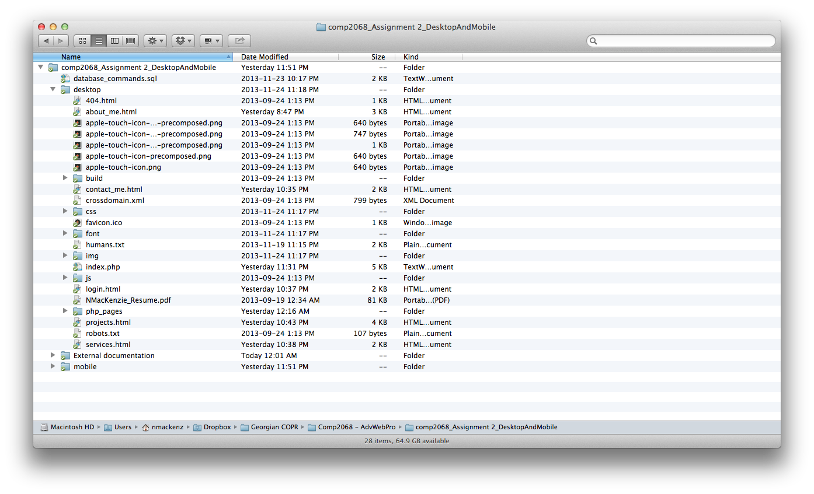

Mobile

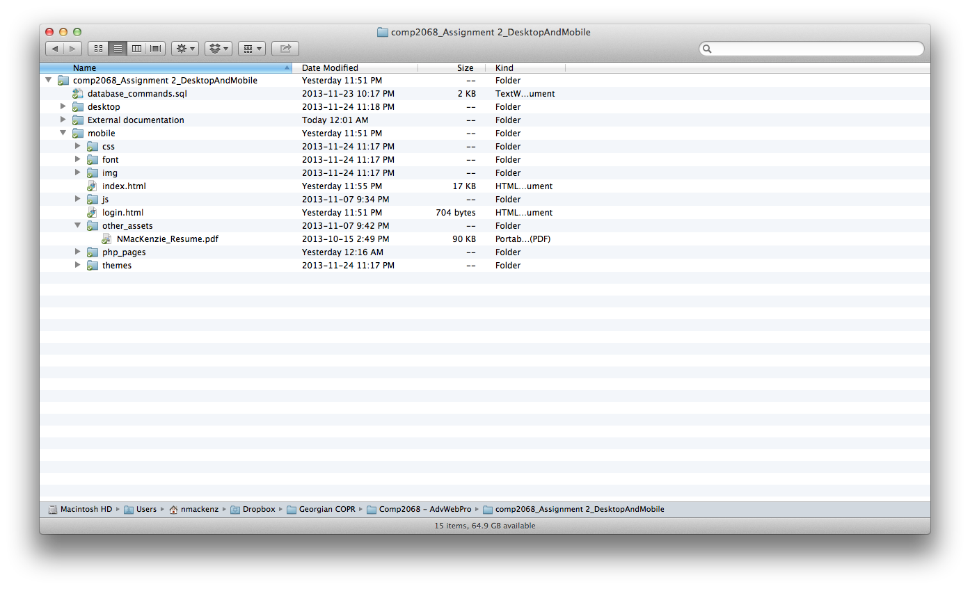

Brief Description:

An improvement over my desktop site, this site is cleaner, easier to read and renders properly. Its goal is to inform the user about my work and myself.

Navigation Bar:

|  |  |
| --- | --- |
| Homepage with image button links | Every other page |
|  |  |

Desktop Version



Colours Section:

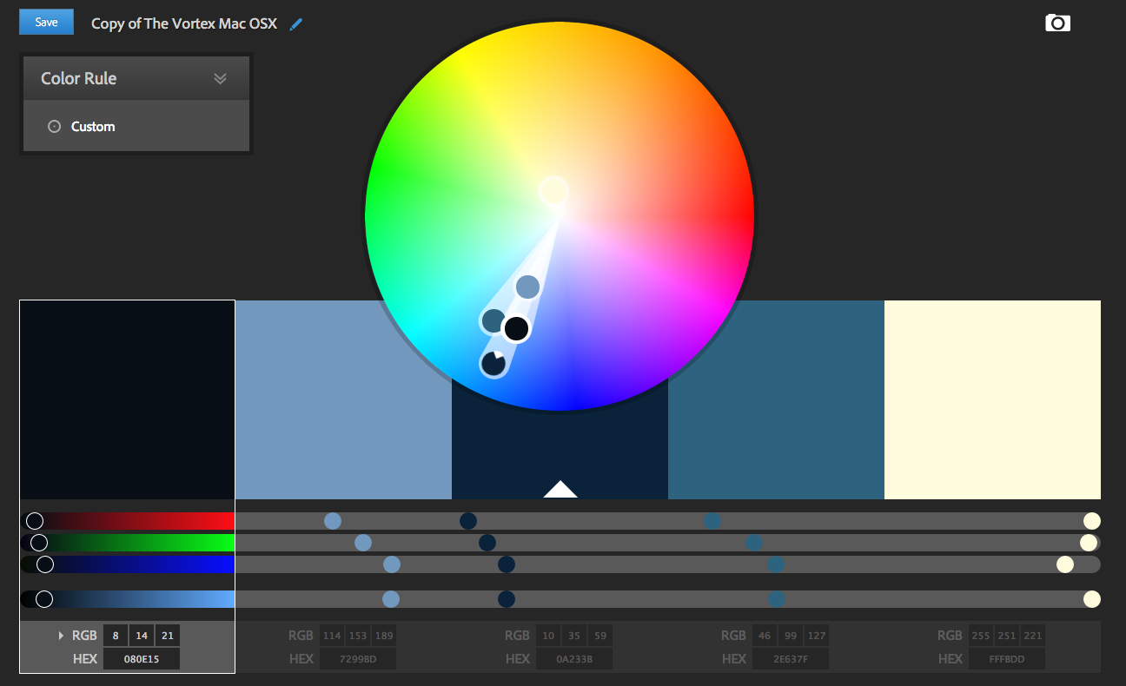

Typography:

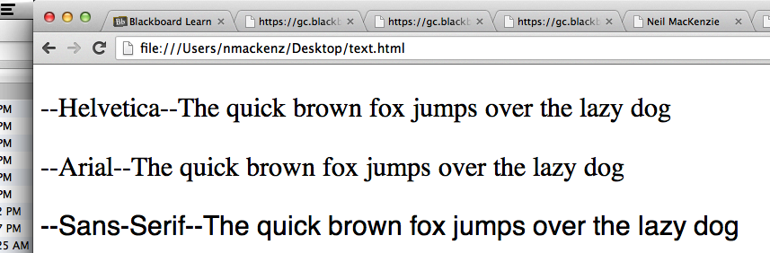

Branding

|  |
| --- |
|  |
|  |

Optional Site Features

* The site features the ability to insert, delete and modify business contacts
* The site features the ability to insert, delete and modify administrators depending on user access level. Level 3 is highest and can add, delete and modify anyone. Level 2 can only see other administrators and add/delete/modify business contacts. Level 1 is not allowed into the Administrative area but can add/delete/modify business contacts
* Every modification page has a cancel button

*For reference here are the available logins.

**Every password is abcd except Q, his password is Q.

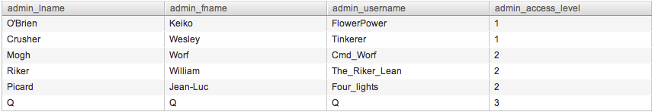

Miscellaneous

* Fixed misspelling of Services in my navbar on the desktop site
* Cleaned up the projects page

**NEW** <http://webdesign4.georgianc.on.ca/~200249489/comp2068/assignment2/desktop/projects.html>

**OLD** <http://webdesign4.georgianc.on.ca/~200249489/comp2068/assignment1/projects.html>

* Changed the layout on the front page so the slider doesn’t overlap anymore

**NEW** <http://webdesign4.georgianc.on.ca/~200249489/comp2068/assignment2/desktop/index.php>

**OLD** <http://webdesign4.georgianc.on.ca/~200249489/comp2068/assignment1/index.html>

* Cleared up some of the comments from the boilerplate